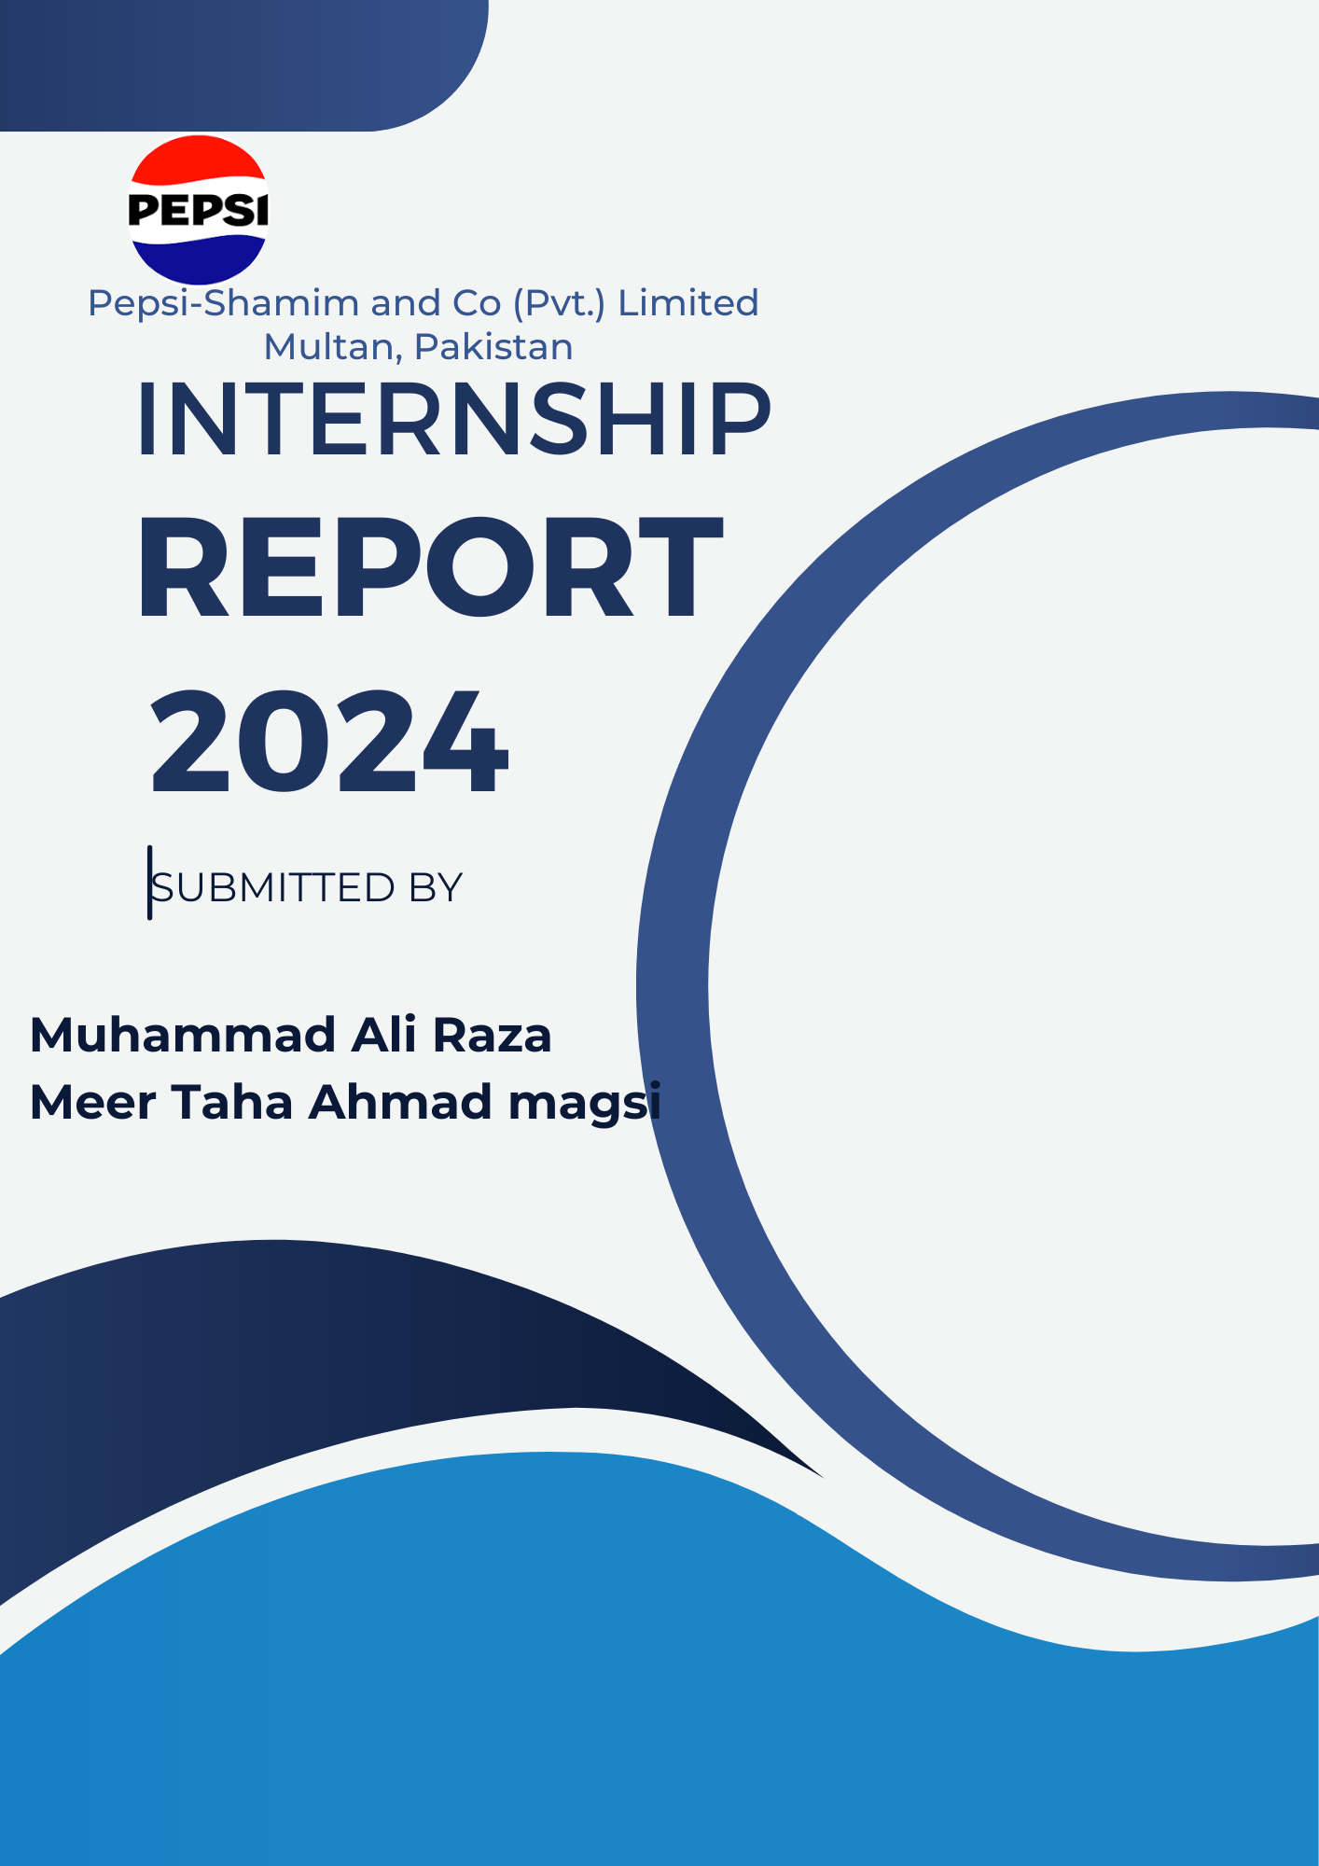

1. Introduction
This report documents our joint internship experience at Pepsi-Shamim & Co. (Pvt.) Limited, Multan, where we engaged in the beverage production process. Our primary focus was on the operation and maintenance of critical machinery, specifically the two 40 bar PET compressors from AF Company, utilized in the blow molding process for plastic bottles. These compressors are crucial for shaping bottles of various sizes on the SBO 8 and SBO 16 machines. Throughout the internship, we gained practical experience in troubleshooting and maintaining these systems, addressing issues such as conveyor irregularities and equipment inefficiencies. The report includes detailed air consumption calculations for different bottle sizes and presents practical solutions aimed at optimizing production efficiency and maintaining high-quality standards. This experience has been invaluable in bridging our academic knowledge with real-world industry practices.
2. Compressor Specifications
SBO 8 Compressor
- Flow Rate: 1320 m³/min
- Bottle Sizes: 345ml, 500ml, 1000ml, 1500ml
- Production Rate: 16,000 bottles per hour
SBO 16 Compressor
- Flow Rate: 2400 m³/min
- Bottle Sizes: 1000ml, 1500ml, 2L,2.5L
- Production Rate: 28,800 bottles per hour
3. Air Consumption Calculations
3.1 Calculation Methodology
The amount of air required to blow each bottle is determined by the volume of the bottle and the pressure applied during the blow molding process. Given that the compressors operate at a pressure of 40 bar, the air consumption can be calculated using the following formula:
Air Consumption (m³/min) = Volume of Bottle (L) × Number of Bottles per Hour × Pressure
60 × 1000

Where:
- The volume of the bottle is converted to liters.
- The pressure is in bar.
- The result is divided by 60 (to convert minutes to hours) and 1000 (to convert liters to cubic meters).
  - SBO 8 Air Consumption
- 345ml Bottles:
- Volume: 0.345 L
- Production Rate: 16,000 bottles per hour
- Pressure: 40 bar
Calculation:

Air Consumption =
0.345 × 16, 000 × 40

60 × 1000

= 3.68 m³/min

- 500ml Bottles:
Volume: 0.500 L
Production Rate: 16,000 bottles per hour Pressure: 40 bar
Calculation:

Air Consumption =
0.500 × 16, 000 × 40

60 × 1000

= 5.33 m³/min

- 1000ml Bottles:
Volume: 1.000 L
Production Rate: 16,000 bottles per hour Pressure: 40 bar
Calculation:
1.000 × 16, 000 × 40
Air Consumption = = 10.67 m³/min
60 × 1000
- 1500ml Bottles:
Volume: 1.500 L
Production Rate: 16,000 bottles per hour Pressure: 40 bar
Calculation:

Air Consumption =

1.500 × 16, 000 × 40

60 × 1000

= 16.00 m³/min

3.3 SBO 16 Air Consumption

  - 1000ml Bottles:

Volume: 1.000 L
Production Rate: 28,800 bottles per hour Pressure: 40 bar
Calculation:

Air Consumption =
1.000 × 28, 800 × 40

60 × 1000

= 19.20 m³/min

  - 1500ml Bottles:
Volume: 1.500 L
Production Rate: 28,800 bottles per hour Pressure: 40 bar
Calculation:

Air Consumption =
1.500 × 28, 800 × 40

60 × 1000

= 28.80 m³/min

  - 2L Bottles:
Volume: 2.000 L
Production Rate: 28,800 bottles per hour Pressure: 40 bar
Calculation:

Air Consumption =
2.000 × 28, 800 × 40

60 × 1000

= 38.40 m³/min

  - 2.5L Bottles
Volume: 2.5 L
Production Rate: 28,800 bottles per hour
Pressure: 40 bar

Calculation:

Air Consumption =
2.5 × 28, 800 × 40
60 × 1000

=48 m³/min
4.Practical Solutions and Recommendations
4.1 Optimization of Air Consumption
During our internship, we observed that efficient air consumption is critical for the cost-effective operation of the blow molding process. We recommend regular maintenance and calibration of the PET compressors to ensure they operate at optimal efficiency. This includes checking for leaks, ensuring proper sealing of bottle molds, and monitoring the pressure settings. Implementing a real-time monitoring system can help track air usage and detect anomalies, allowing for prompt corrective actions.
4.2 Addressing Conveyor System Issues
The conveyor systems responsible for transporting empty bottles were found to have issues such as blockages and sensor malfunctions. We suggest the following measures to improve the reliability and efficiency of the conveyor systems:
- Routine Inspections and Maintenance: Establish a schedule for regular inspections and preventive maintenance to identify and resolve potential issues before they cause significant disruptions.
- Upgrading Sensors: Replace outdated sensors with more accurate and reliable models to enhance detection and reduce false alarms.
- Operator Training: Provide comprehensive training for operators to properly handle the conveyor systems and quickly respond to any operational issues.
  - Quality Control and Standards
Maintaining high-quality standards is crucial for ensuring product safety and customer satisfaction. We recommend the following quality control measures:
- Stringent Quality Checks: Implement rigorous quality checks at each stage of the production process, from preform handling to the final packaging of bottles.
- Continuous Improvement Programs: Establish a continuous improvement program that involves regular reviews of production processes, quality standards, and employee feedback. This can help identify areas for improvement and implement best practices.
  - Conclusion
Our internship at Pepsi-Shamim & Co. (Pvt.) Limited, Multan, provided us with invaluable practical experience in a high-paced beverage manufacturing environment. The insights gained into the operations of PET compressors, conveyor systems, and packaging machinery have enriched our understanding of industrial processes. The recommendations provided in this report aim to enhance production efficiency, ensure consistent quality, and optimize resource usage. We are confident that implementing these solutions will contribute to the overall operational excellence of the facility.

